Deep Learning in the AI Ecosystem

You've probably heard the terms "AI," "machine learning," and "deep learning" thrown around interchangeably in tech conversations. But here's the thing: they're not the same, and understanding their relationship is like having a map in unfamiliar territory. In this lesson, we'll discover where deep learning fits in the grand scheme of AI. By the end, you'll be able to confidently explain not just what deep learning is, but why it represents such a significant leap forward in how machines learn.
1. What Is Deep Learning?
1.1 The Brain-Inspired Approach
Let's start with a question: How does your brain recognize a friend's face in a crowd? You don't consciously think "oval face, brown eyes, specific nose shape", you just know. Your brain has learned this through experience, processing visual information through billions of interconnected neurons that fire in patterns.
Deep learning attempts to replicate this process using artificial neural networks. These are computer systems modeled (loosely) after your brain's architecture. Instead of biological neurons, we have mathematical functions organized into layers. And just as your brain doesn't need someone to write explicit instructions for every face you might encounter, deep learning models discover patterns on their own.
The "deep" part? That refers to having multiple layers of these artificial neurons stacked together, each layer learning to recognize increasingly sophisticated patterns.
1.2 Learning From Data
Now, imagine teaching a child what a cat is. You don't hand them a manual with measurements and rules. You show them cats, many cats, until they intuitively grasp what makes a cat a cat. Deep learning works remarkably similarly.
Instead of programming explicit rules (which would be nearly impossible for complex tasks), we provide the network with examples. We feed it thousands of cat images, and it gradually adjusts its internal connections, like your brain strengthening certain neural pathways through repetition, until it can recognize cats it's never seen before.
Example: Think about spam filters. An old-school approach might check for specific words like "free" or "winner." But a deep learning model? It examines thousands of spam and legitimate emails, learning subtle patterns in word combinations, sentence structures, and even writing styles that distinguish spam—patterns so complex that even humans might not consciously recognize them.
1.3 The Power of Scale
While many traditional methods plateau when you give them more data, deep learning models often get better and better. It's as if the more examples you show them, the more nuanced their understanding becomes. This hunger for data is both deep learning's superpower and its main requirement: you need substantial datasets to unlock its full potential.
2. Deep Learning's Position in the AI Hierarchy
2.1 The Three-Tier Structure
Let's zoom out and see the bigger picture. Think of AI as a set of Russian nesting dolls, each one fitting inside the next:
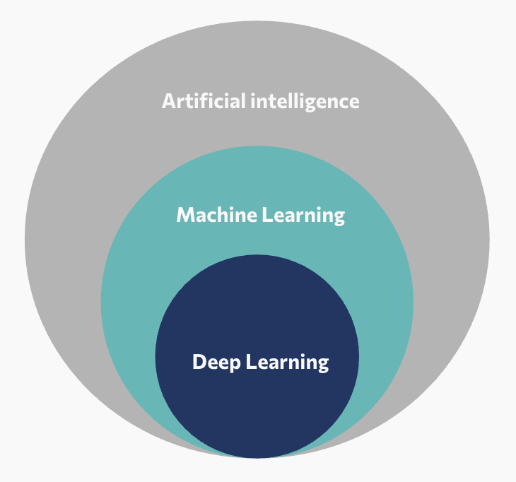
Figure - Deep Learning in the AI Ecosystem
- Artificial Intelligence is the outermost doll—the most general concept. It encompasses any technique that makes computers behave intelligently, from the simple chess programs of the 1960s to today's sophisticated systems. Even a thermostat using if-then rules technically falls under AI.
- Machine Learning is the next doll—more specific. This is where computers learn from experience rather than following pre-programmed rules. Show a machine learning algorithm enough examples, and it will find patterns and make predictions. This includes everything from recommendation systems to fraud detection.
- Deep Learning is the innermost doll—the most specialized. It's a particular approach to machine learning that uses those multi-layered neural networks we discussed. It's the newest kid on the block, but it's solving problems that seemed impossible just a decade ago.
2.2 Deep Learning's Domains
Deep learning has revolutionized several distinct areas, each solving different types of problems:
- Computer Vision: Teaching machines to "see" and understand images and videos. This powers facial recognition in your phone, medical diagnosis from X-rays and MRI scans, self-driving cars that detect pedestrians and traffic signs, and quality control systems in manufacturing that spot defects humans might miss.
- Natural Language Processing (NLP): Helping computers understand and generate human language. You interact with this daily through chatbots and virtual assistants, language translation apps, email auto-complete suggestions, and sentiment analysis that helps companies understand customer feedback at scale.
- Image and Content Generation: Creating new, original content from descriptions or examples. This includes AI art generators that create images from text prompts, tools that enhance photo quality or remove backgrounds, video generation and editing systems, and even AI that generates realistic human voices.
- Speech Recognition and Synthesis: Converting between spoken words and text. Think voice assistants like Siri or Alexa, real-time transcription services, voice-to-text for accessibility, and text-to-speech systems that sound increasingly natural.
- Recommendation Systems: Predicting what you might like based on patterns in massive datasets. This powers what shows up in your Netflix queue, YouTube recommendations, Spotify's discover playlists, and e-commerce product suggestions.
- Time Series and Forecasting: Analyzing patterns over time to predict future events. Applications include stock market prediction, weather forecasting, predicting equipment maintenance needs before failures occur, and energy demand forecasting for power grids.
The common thread: All these domains deal with complex, unstructured data where patterns are too intricate to code by hand. Deep learning discovers these patterns automatically from examples.
2.3 Traditional ML vs. Deep Learning
So when should you use deep learning versus other machine learning approaches? Let's get practical.
Imagine you're trying to predict house prices. You have a neat spreadsheet with clear columns: square footage, number of bedrooms, location, year built. Traditional machine learning algorithms like decision trees or linear regression shine here. They're fast, efficient, and interpretable—you can explain exactly why the model made each prediction.
But now imagine you're trying to identify diseases from medical images, or translate speech from one language to another in real-time. These tasks involve messy, unstructured data where the relevant patterns aren't obvious. This is deep learning territory.
Traditional Machine Learning excels when:
- You have structured, tabular data with clear features
- Your dataset is relatively small (hundreds to thousands of examples)
- You need to understand and explain the model's decisions
- Computational resources are limited
Deep Learning becomes the better choice when:
- You're working with images, audio, text, or other unstructured data
- You have large amounts of data (typically tens of thousands of examples or more)
- The patterns are too complex for manual feature engineering
- You have access to significant computational power (like GPUs)
Common pitfall: Many beginners reach for deep learning first because it's exciting and powerful. But remember: if a simpler approach solves your problem effectively, use it. Deep learning is a powerful tool, not a universal solution. It's like using a chainsaw when scissors would do, sometimes overkill creates more problems than it solves.
The key insight? Traditional ML and deep learning aren't competitors: they're different tools in your toolbox, each suited for different jobs.
Key Takeaways
- Deep learning is a specialized subset of machine learning that uses multi-layered artificial neural networks to learn hierarchical patterns, much like how our brains process information from simple to complex
- The AI ecosystem follows a nested structure: Artificial Intelligence (broadest concept) contains Machine Learning (learning from data), which contains Deep Learning (multi-layered neural networks)
- The "deep" refers to multiple layers that automatically learn features at different levels of abstraction—from simple patterns in early layers to complex concepts in later layers
- Deep learning excels with large datasets and unstructured data like images, audio, and text, while traditional ML often works better for smaller, structured datasets with interpretable requirements
- The choice between traditional ML and deep learning isn't about which is "better"—it's about matching the right tool to your specific problem, data, and constraints

